Colorado Trucking Selenium Testing

Jeff Ardolino

Quality Assurance

This test was designed to take a screenshot of the search results based on city name. An array of city names was used in the test and a screenshot was taken of each grouping of markers. Each grouping was located at the correct city location on the map.

**Selenium Code**

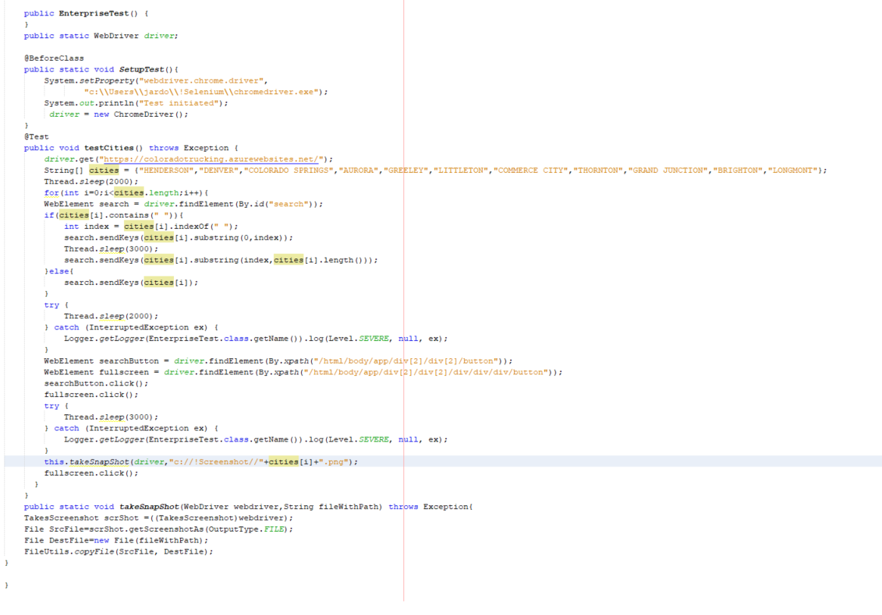**Screenshots**

**AURORA**

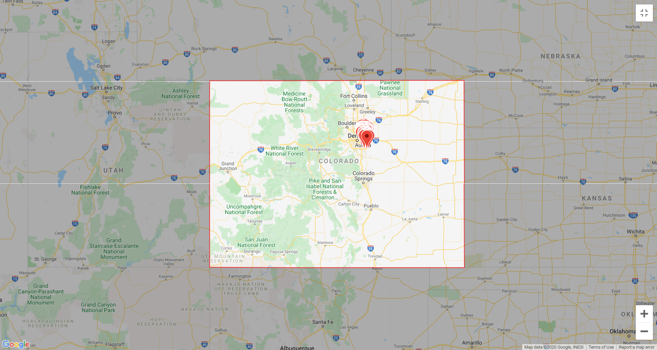

**BRIGHTON**

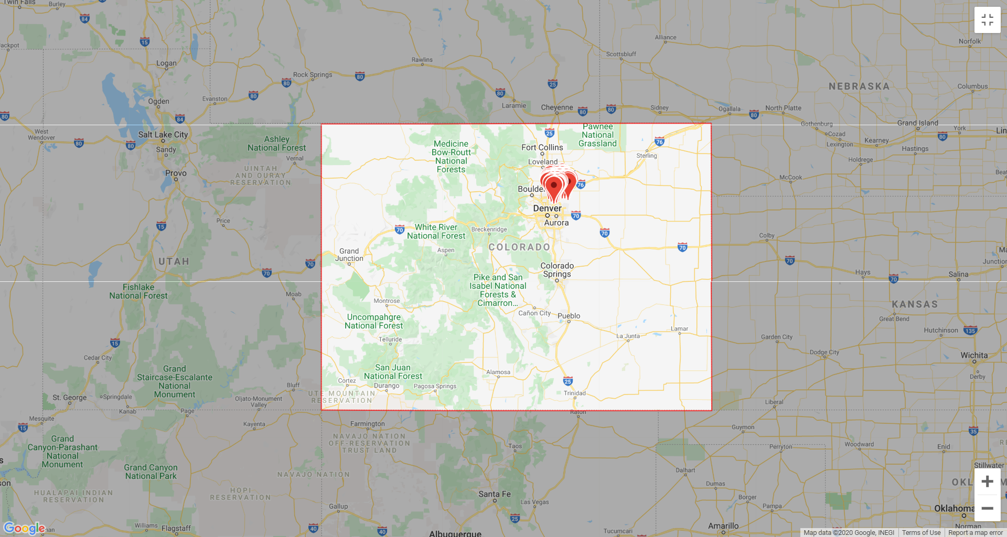

**COLORADO SPRINGS**

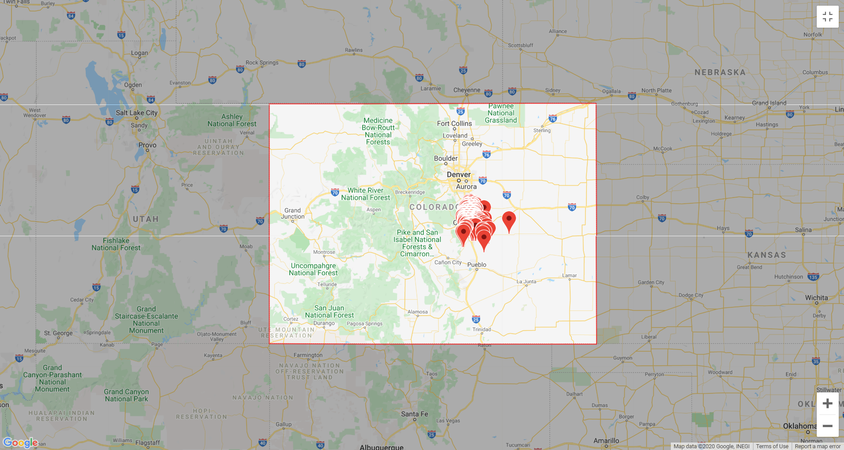

**COMMERCE CITY**

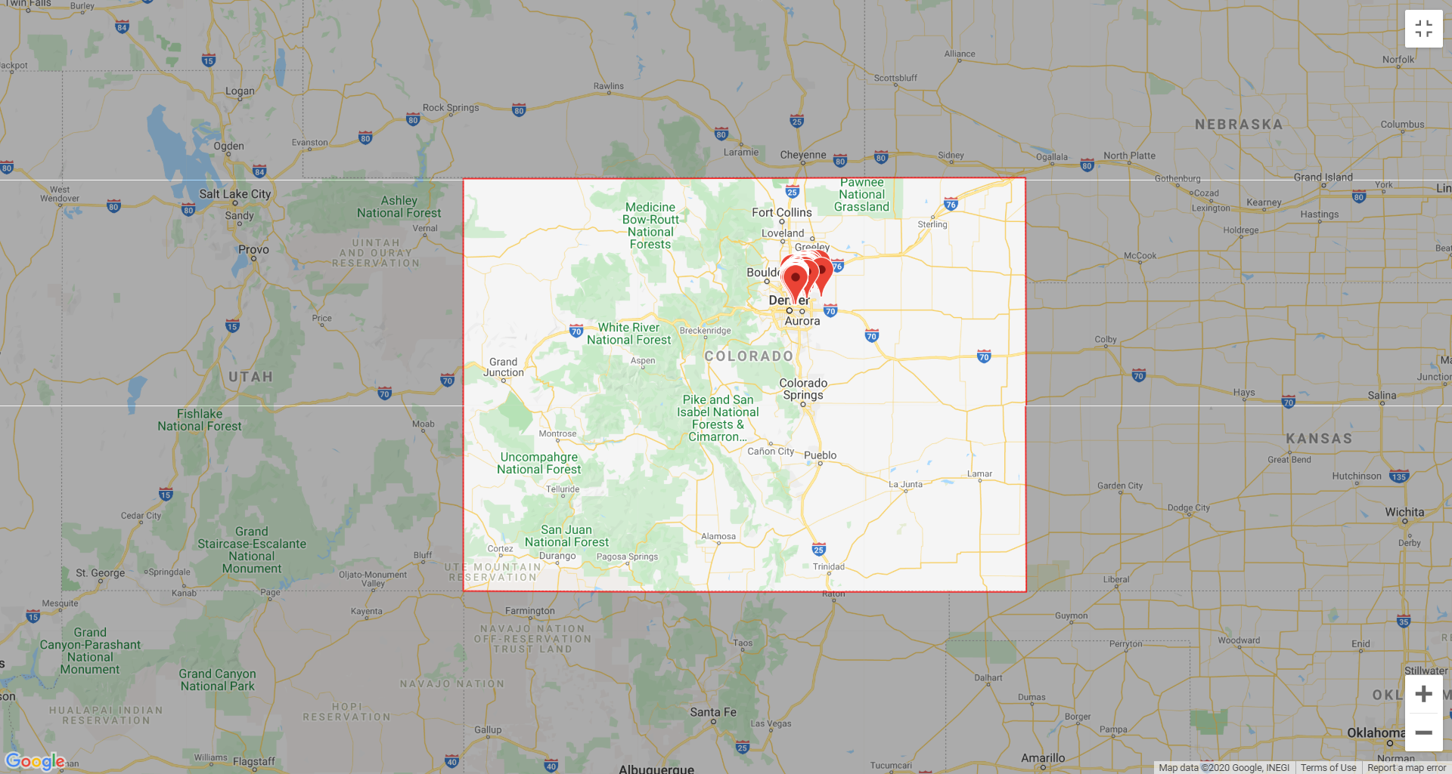

**DENVER**

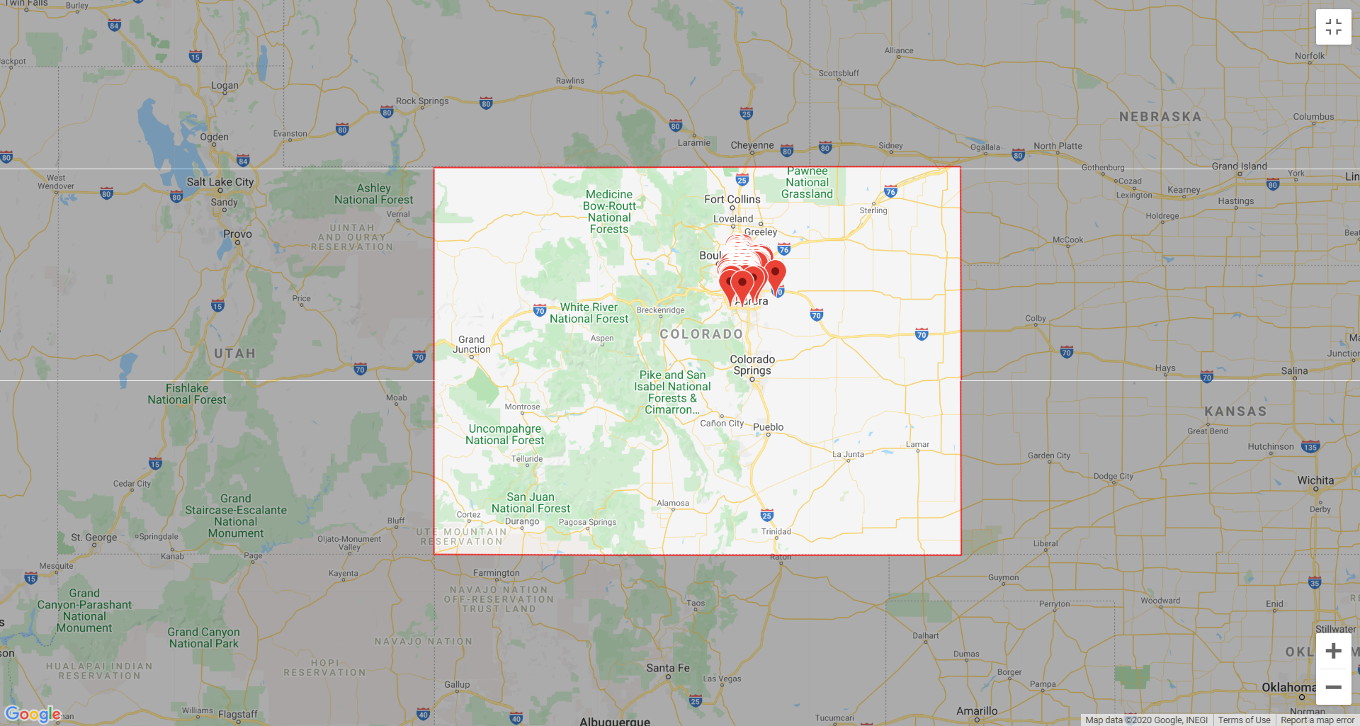

**GRAND JUNCTION**

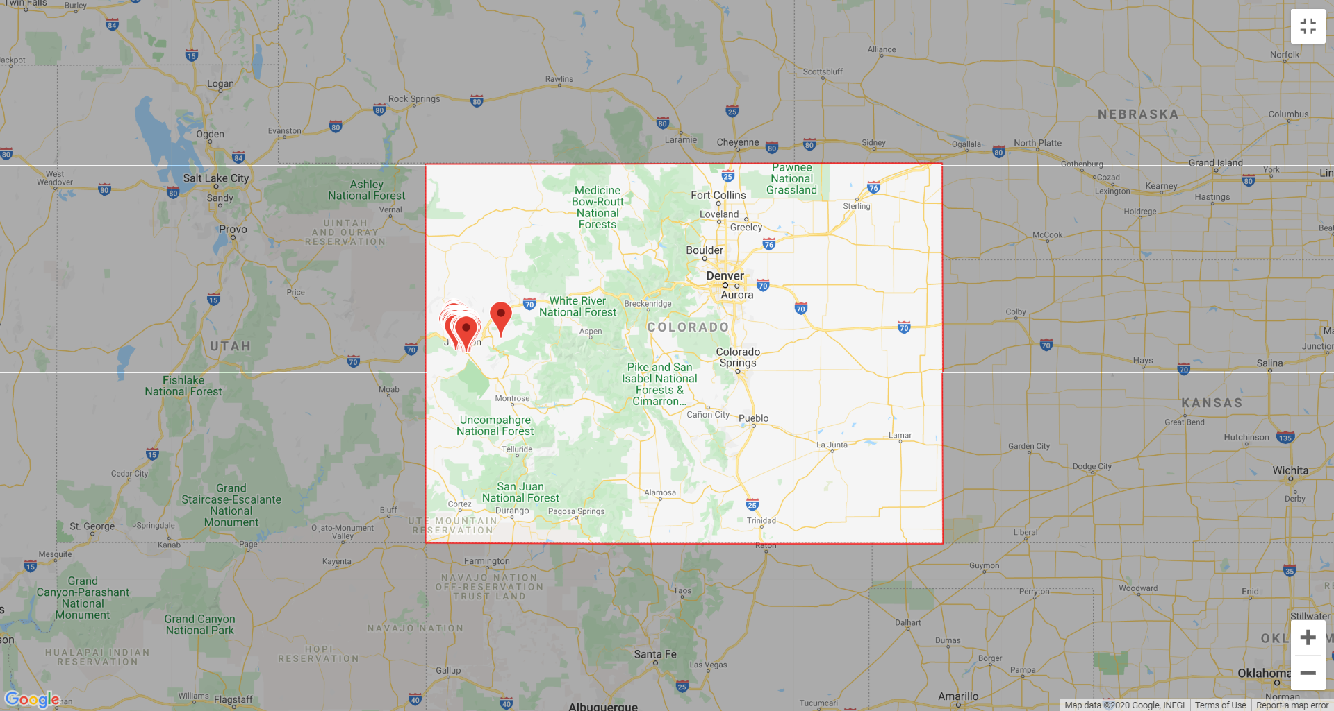

**GREELEY**

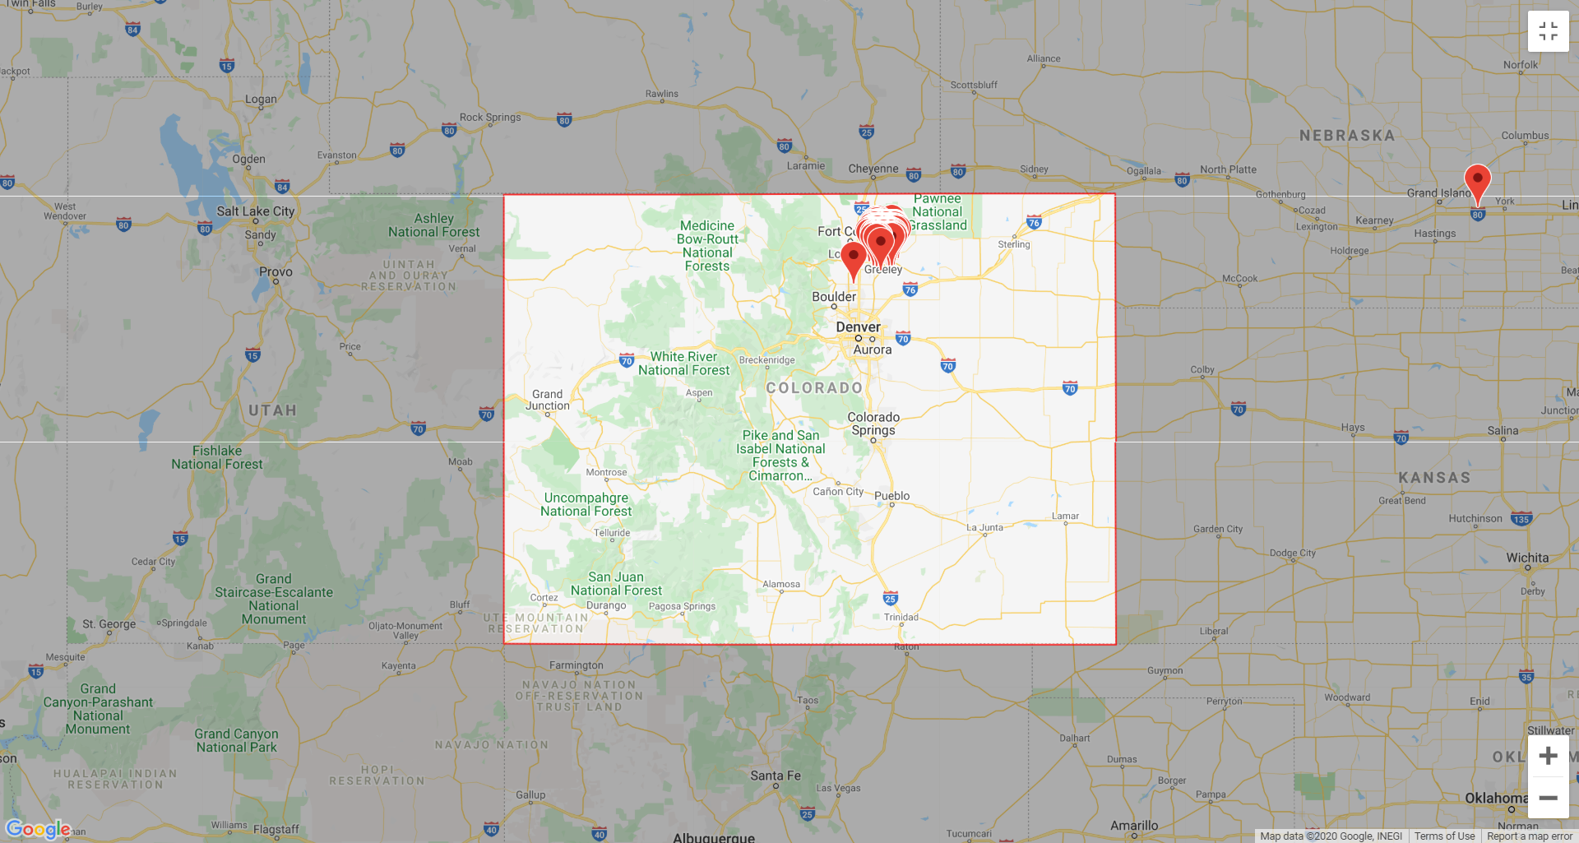

**HENDERSON**

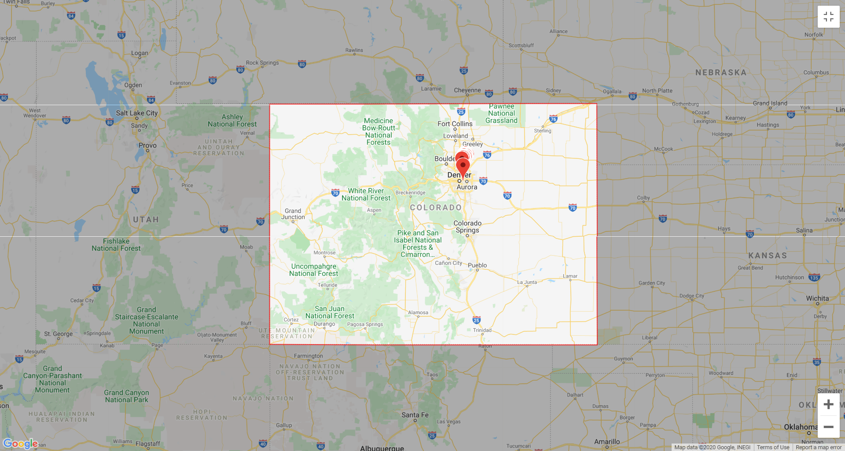

**LITTLETON**

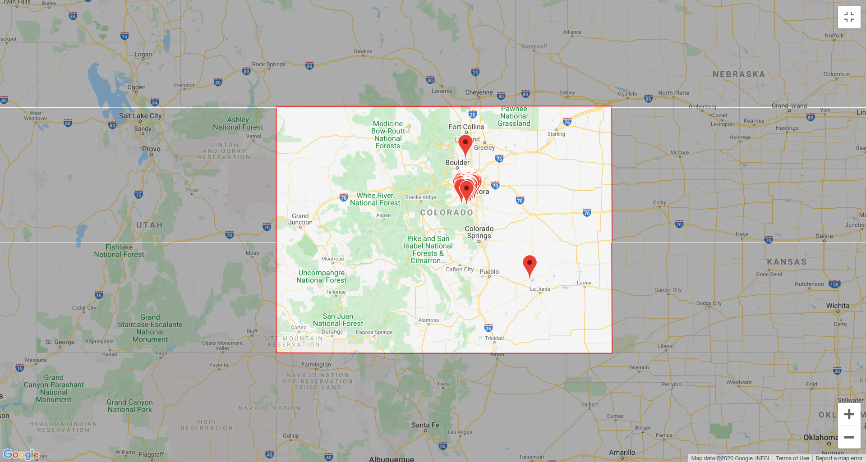

**LONGMONT**

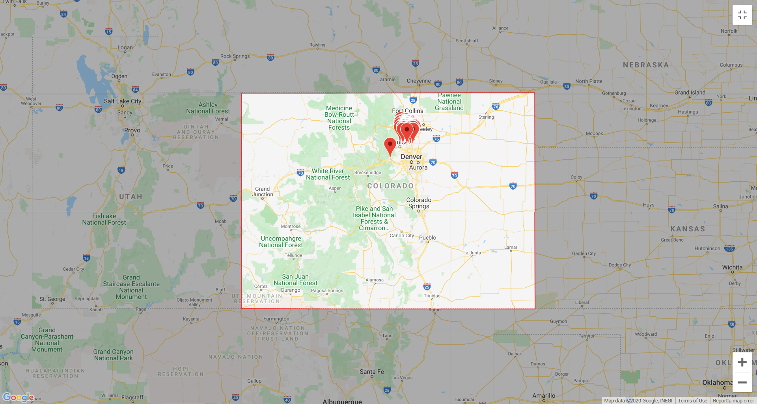

**THORNTON**

